11111011 FROM BASE 2 TO 10

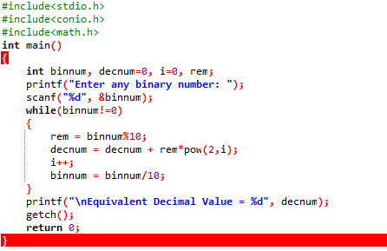

OUTPUT

